Titanic Data analysis DATA SET DESCRIPTION Column 1 : PassengerId Column 2 : Survived (survived=0 & died=1) Column 3 : Pclass Column 4 : Name Column 5 : Sex Column 6 : Age Column 7 : SibSp Column 8 : Parch Column 9 : Ticket Column 10 : Fare Column 11 : Cabin Column 12 : Embarked

Problem statement Write a custom key to evaluate the number of people who died and the number of people who survived, along with their genders.

//Mapper Class

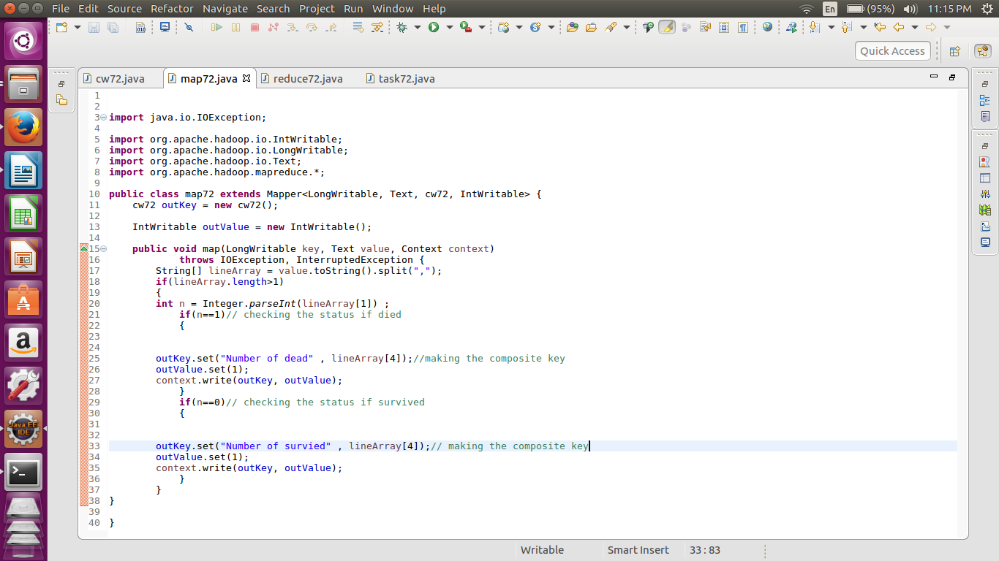

//Reducer class

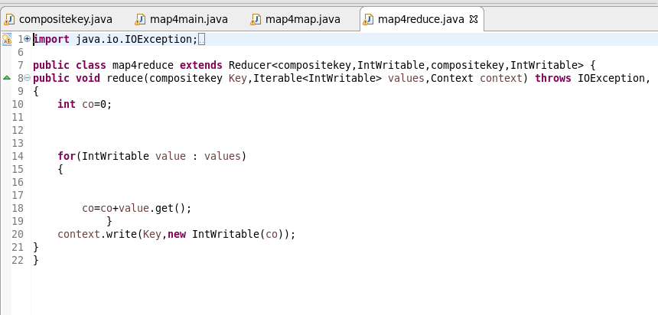

//Writable Comparable

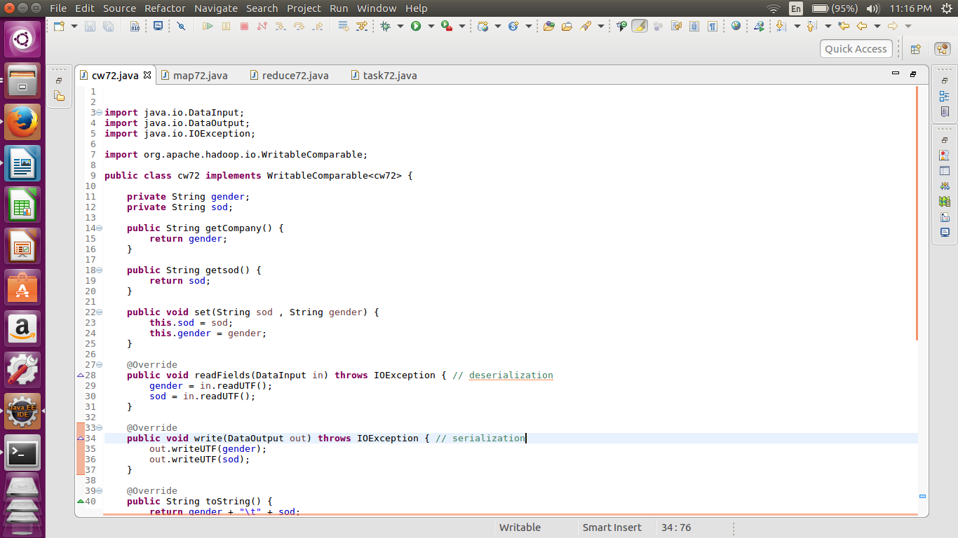

//driver class

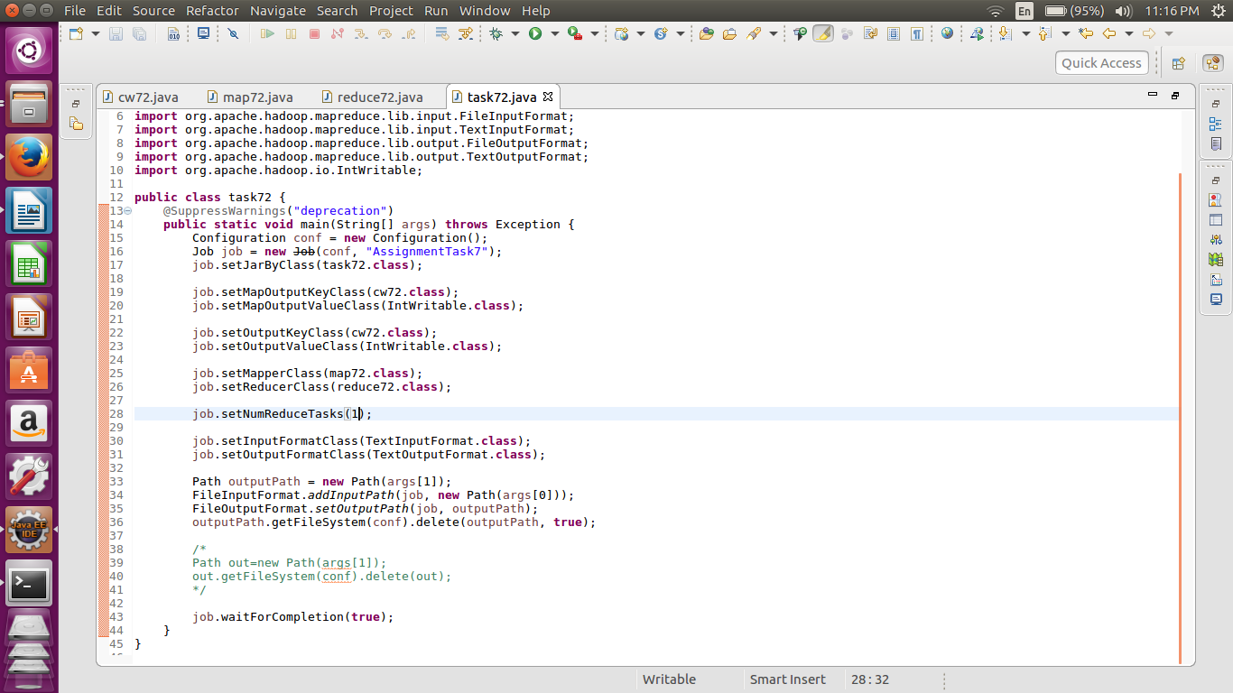

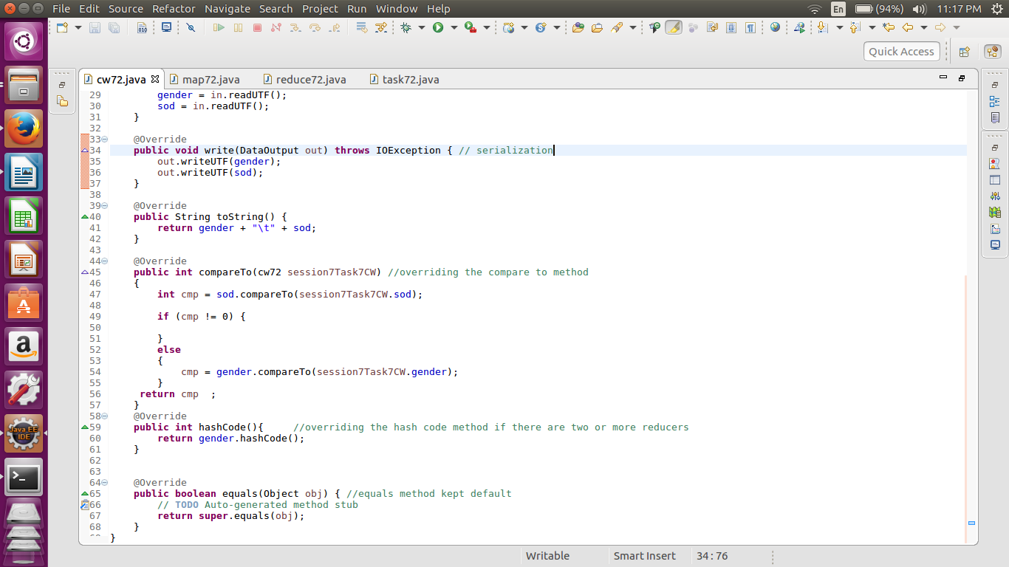

//output

